**WELCOME TO RECIPE SHARING APP**

**OUTPUT:**

**1.Registration for Recipe sharing app**

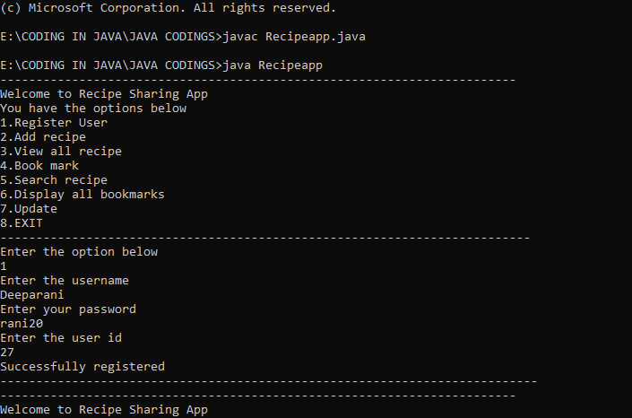

**2.Add Recipe:**

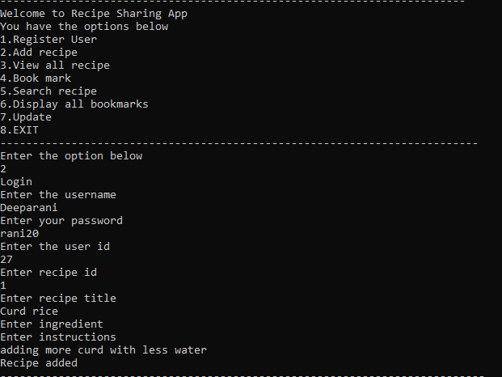

**3.View all recipes available**

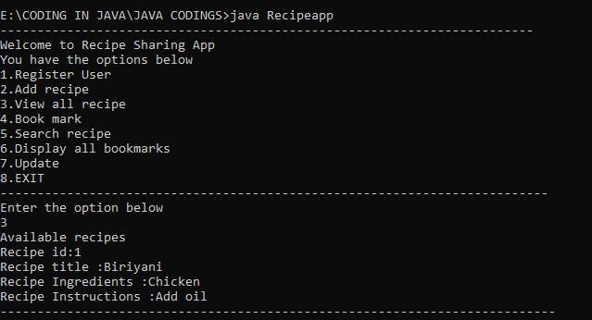

**4.Bookmarked Recipes:**

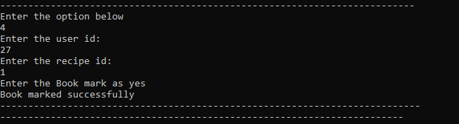

**5.Key to search the recipe:**

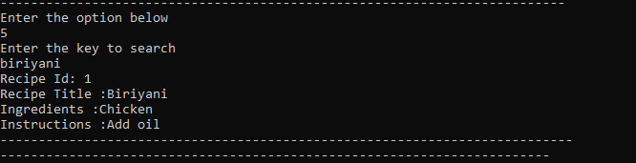

**6.Update the recipe(As per user perspective)**

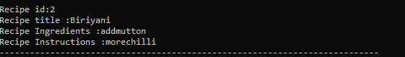

**7.Exit**

